

Name: Apurba Koirala

Reg no: 22BCE3799

Subject Code: BCSE308P

Course Title: Computer Networks Lab

Lab Slot: L31 + L32

Guided by: Dr. Arivoli A

Lab Assessment 3

Question no. 1

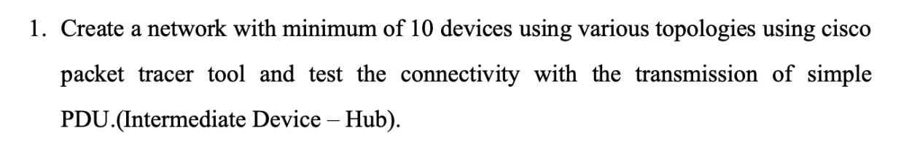

Solution;

RING TOPOLOGY:

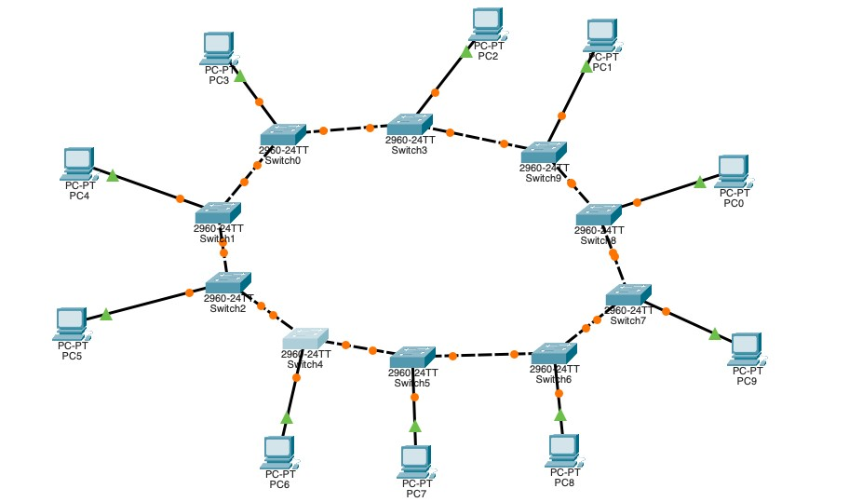

PC0:

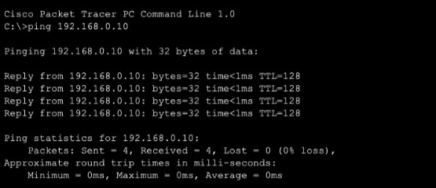

PC4:

PC6:

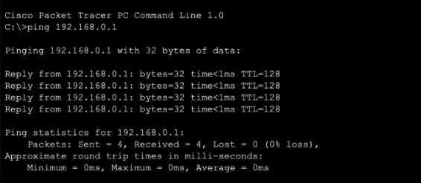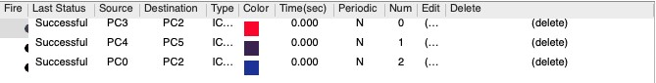

STAR TOPOLOGY:

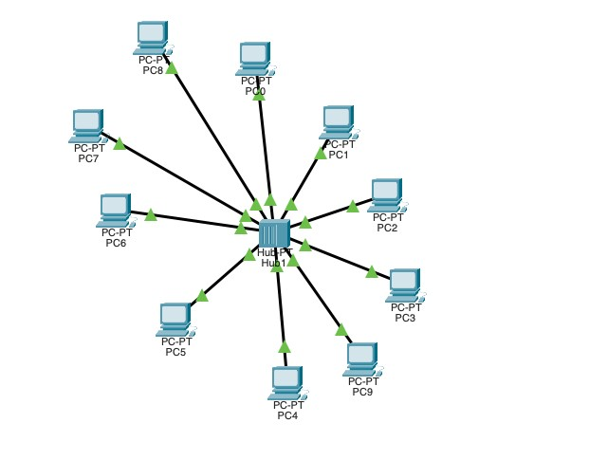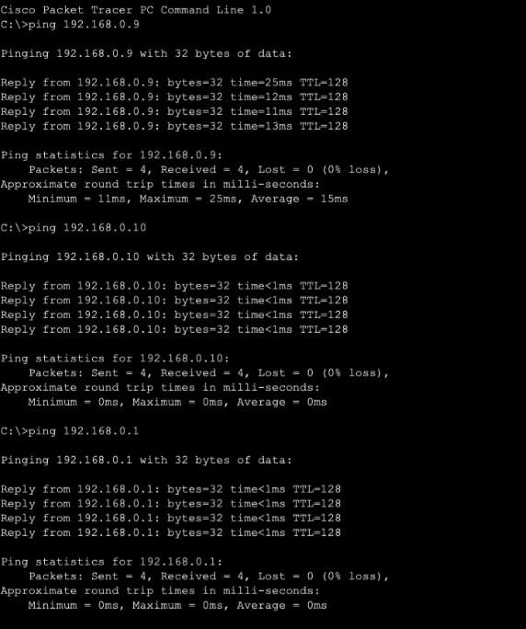

MESH TOPOLOGY:

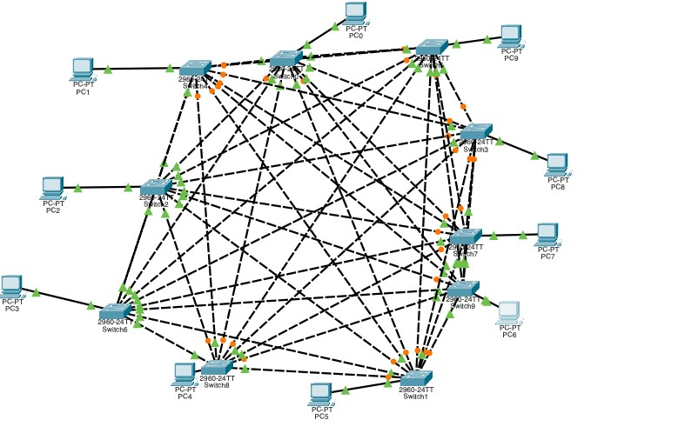

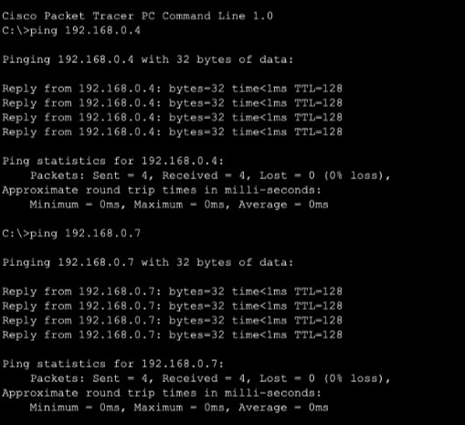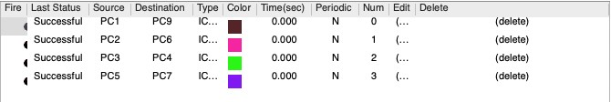

BUS TOPOLOGY:

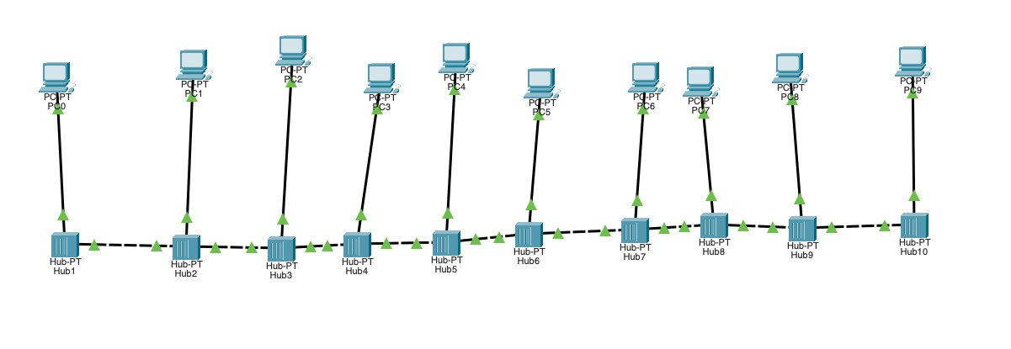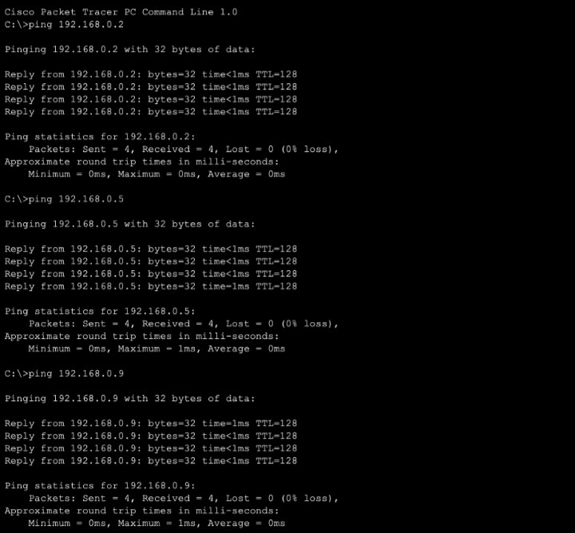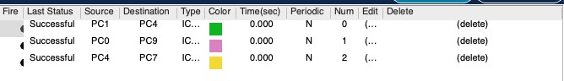

Question no. 2:

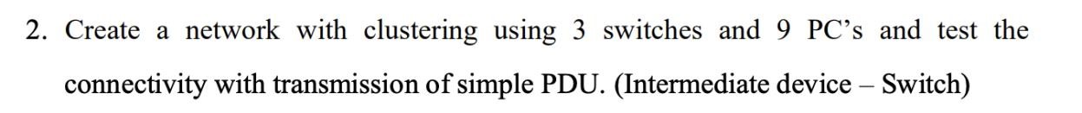

Solution;

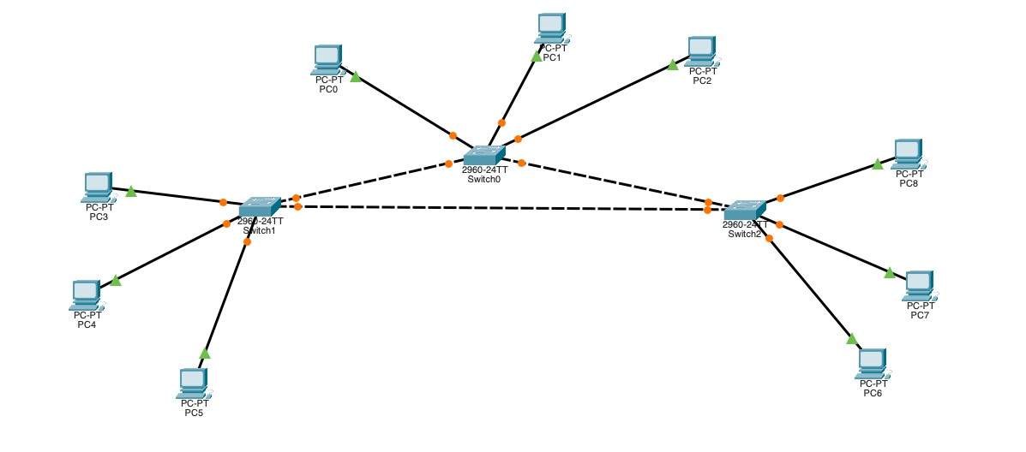

Transmission using simple PDU results:

Question no. 3

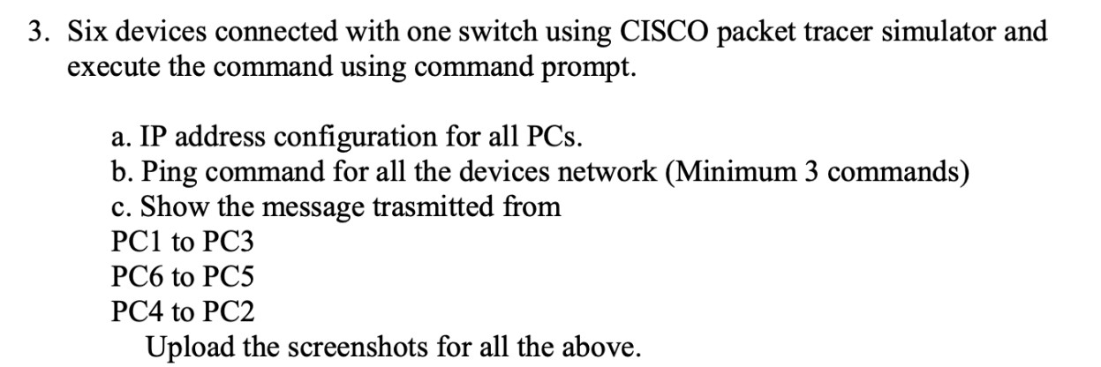

Solution;

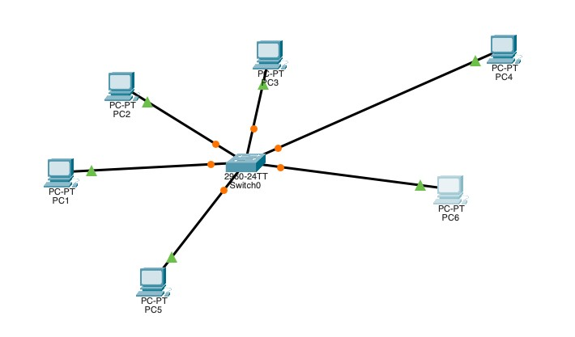 a. IP address configuration for all PCs

PC1:

PC2:

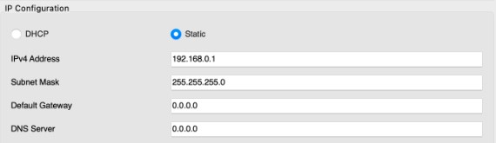

PC3:

PC4:

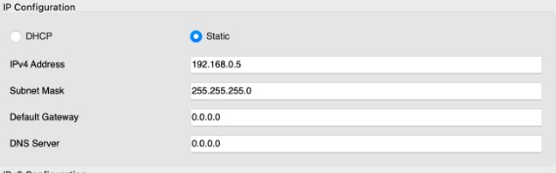

PC5:

PC6;

b. Ping commands for all devices network (Minimum 3 commands)

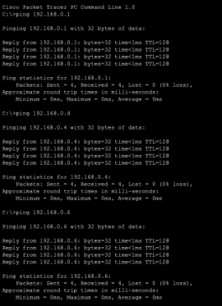

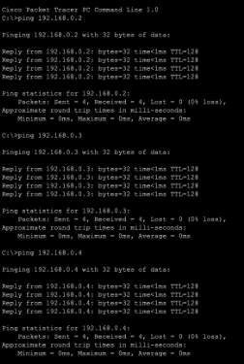

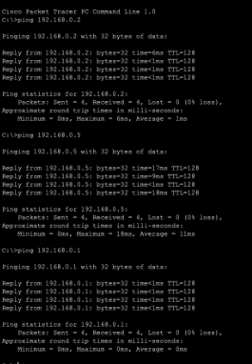

c. Show the message transmitted from

PC1 to PC3

PC6 to PC5

PC4 to PC2

Question no. 4

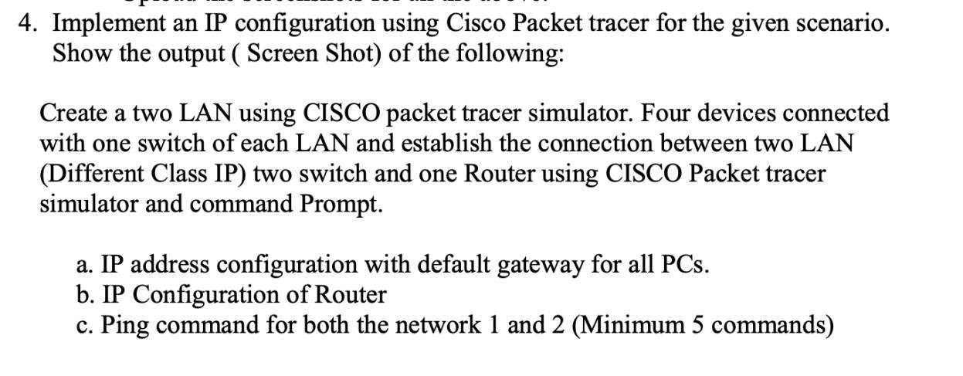

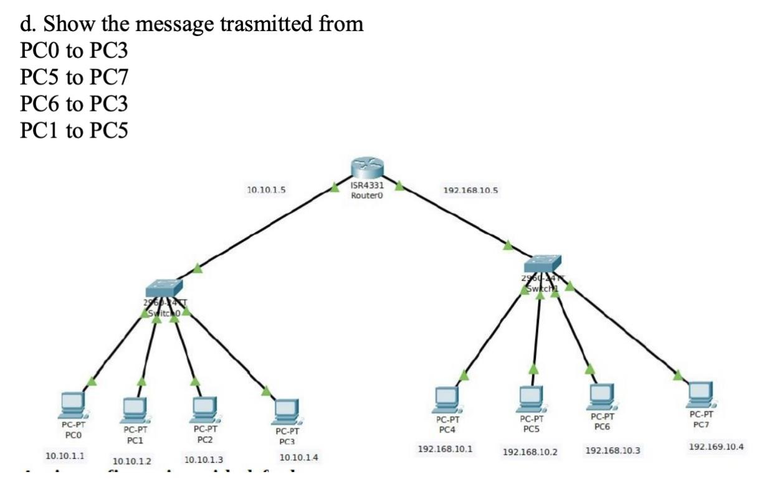

Solution;

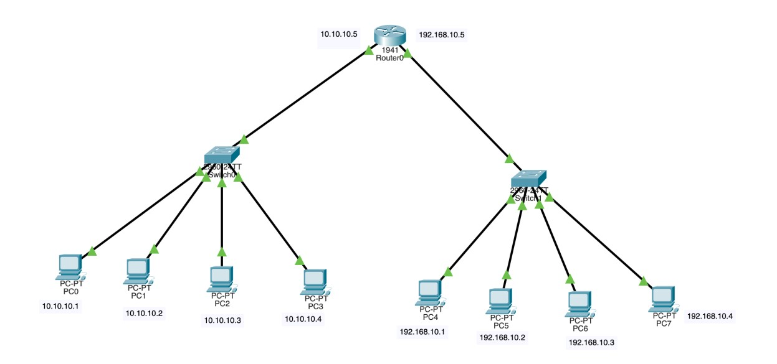

FIG 1

1. IP Configuration and Default Gateway for PCS:

Pc0:

Pc1:

Pc2:

Pc3:

Pc4:

Pc5:

Pc6:

Pc7:

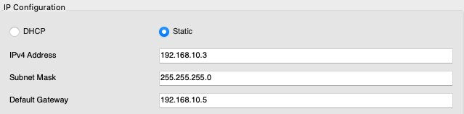

1. IP Configuration of Router

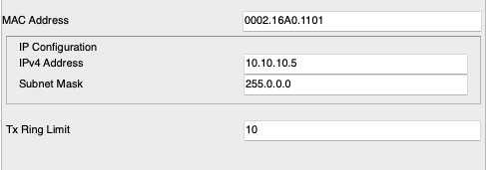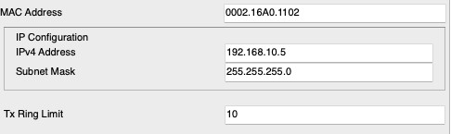

1. Ping command for both network 1 and 2

Network 1

Network 2

1. . Show the message transmitted from

PC0 to PC3

PC5 to PC7

PC6 to PC3

PC1 to PC5

FLOW CONTROL

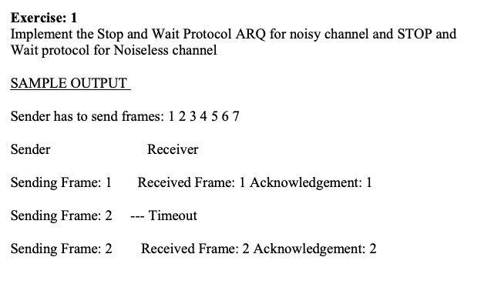

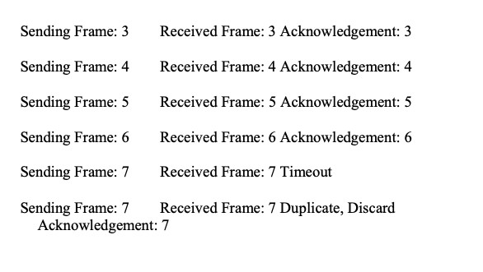

Solution;

#include <stdio.h>

#include <unistd.h>

void send_frame(int frame) {

printf("Sending Frame: %d\n", frame);

sleep(1);

}

void receive_frame(int frame) {

printf("Received Frame: %d\n", frame);

sleep(1);

}

void send_acknowledgement(int ack) {

printf("Acknowledgement: %d\n", ack);

sleep(1);

}

void stop_and_wait_protocol(int frames[], int len) {

int i = 0;

while (i < len) {

int frame = frames[i];

send_frame(frame);

receive_frame(frame); send_acknowledgement(frame);

i++;

if (i < len) {

send_frame(frames[i]);

receive_frame(frames[i]);

send_acknowledgement(frames[i]);

i++; } else {

break;

}

}

}

int main() {

int frames_to_send[] = {1, 2, 3, 4, 5, 6, 7};

int len = sizeof(frames_to_send) / sizeof(frames_to_send[0]); stop_and_wait_protocol(frames_to_send, len);

return 0;

}

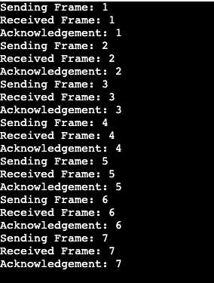

Case 1: Frames lost:

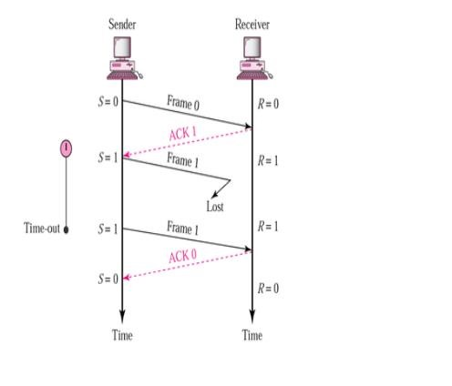

#include <stdio.h>

#include <stdlib.h>

#include <unistd.h>

#include <time.h>

void send_frame(int frame_number) {

printf("Sending Frame %d\n", frame_number);

sleep(1);

}

int receive_ack(int expected_ack) {

int ack = rand() % 2; // Ensures random ack is 0 or 1

sleep(1);

if (ack == expected_ack) {

printf("ACK %d received\n", ack);

return 1;

} else {

printf("ACK %d received, expected ACK %d\n", ack, expected_ack);

return 0;

}

}

void stop_and_wait_arq(int total_frames) {

int frame_number = 0;

int expected_ack = 0;

int frames_sent = 0;

while (frames_sent < total_frames) {

send_frame(frame_number);

if (receive_ack(expected_ack)) {

frame_number = (frame_number + 1) % 2;

expected_ack = (expected_ack + 1) % 2;

frames_sent++;

} else {

printf("Frame %d lost. Retransmitting Frame %d\n", frame_number, frame_number);

}

}

}

int main() {

srand(time(0));

int total_frames = 7; // Total number of frames to send

stop_and_wait_arq(total_frames);

return 0;

}

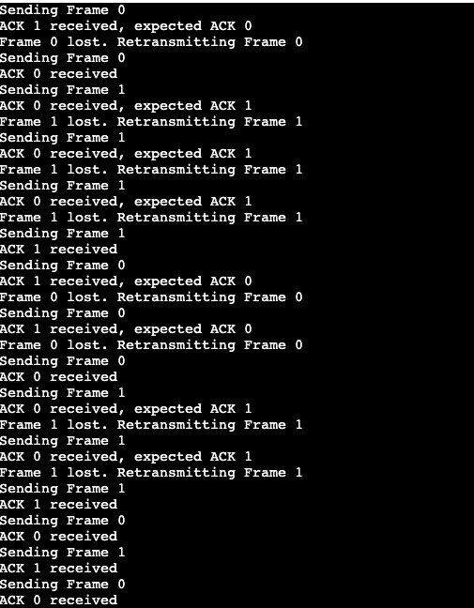

Case 2: ACK Lost

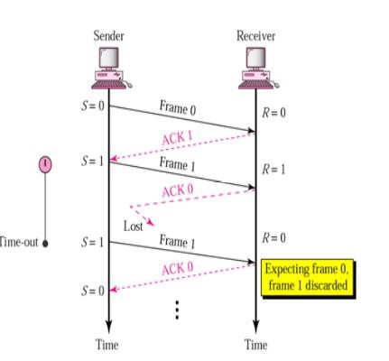

#include <stdio.h>

#include <stdlib.h>

#include <unistd.h>

#include <time.h>

void send_frame(int frame_number) {

printf("Sending Frame %d\n", frame_number);

sleep(1);

}

int receive_ack(int expected_ack) {

int ack = rand() % 2;

sleep(1);

if (ack == expected_ack) {

printf("ACK %d received\n", ack);

return 1; } else {

printf("ACK %d lost\n", ack);

return 0;

}

}

void stop_and_wait_arq(int total_frames) {

int frame_number = 0;

int expected_ack = 0;

int frames_sent = 0;

while (frames_sent < total_frames) {

send_frame(frame_number);

if (receive_ack(expected_ack)) {

frame_number = (frame_number + 1) % 2;

expected_ack = (expected_ack + 1) % 2;

frames_sent++;

} else {

printf("ACK %d lost. Retransmitting Frame %d\n", expected_ack, frame_number);

}

}

}

int main() {

srand(time(0));

int total_frames = 7; // Total number of frames to send

stop_and_wait_arq(total_frames);

return 0;

}

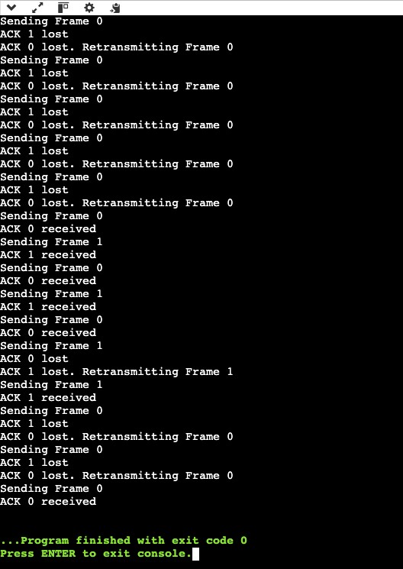

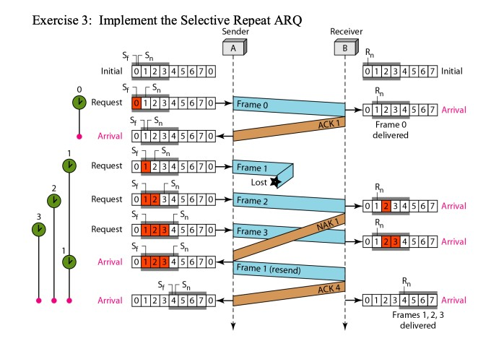

#include <stdio.h>

#include <stdlib.h>

#include <unistd.h>

#include <time.h>

void send_frame(int frame_number) {

printf("Sending Frame %d\n", frame_number);

sleep(1);

}

int receive_ack(int expected_ack) {

int ack = (rand() % 2 == 0) ? expected_ack : -1; // Randomly generate ACK or NAK

sleep(1);

if (ack == expected_ack) {

printf("ACK %d\n", ack);

return 1;

} else {

printf("NAK %d\n", expected_ack);

return 0;

}

}

void selective_repeat_arq() {

int window_size = 3;

int base = 0;

int next_sequence_number = 0;

int frames[] = {0, 1, 2, 3, 4, 5, 6, 7};

int total_frames = sizeof(frames) / sizeof(frames[0]);

while (base < total_frames) {

if (next_sequence_number < base + window_size && next_sequence_number < total_frames) {

int frame_number = frames[next_sequence_number];

send_frame(frame_number);

next_sequence_number++;

}

if (receive_ack(base)) {

base++;

} else {

printf("Resending Frame %d\n", frames[base]);

}

}

}

int main() {

srand(time(0)); // Seed the random number generator

selective_repeat_arq();

return 0;

